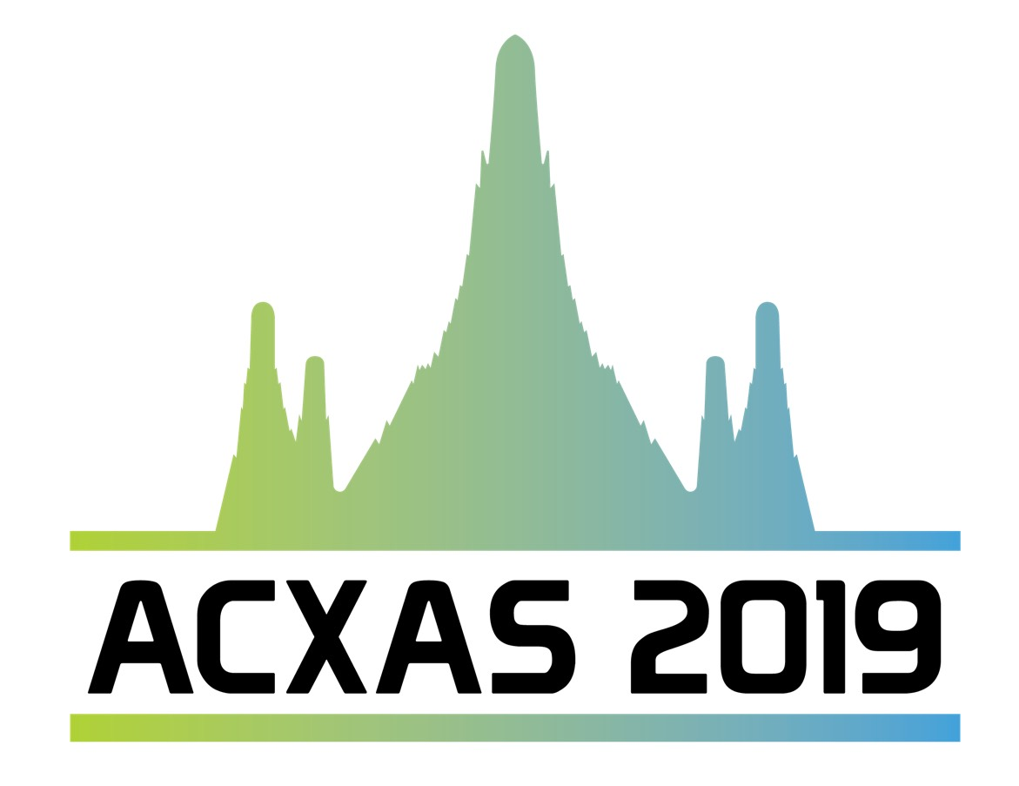
Title (Times New Roman, 14 points, bold, capitalize only the first word, center justified)

Firstname Lastname¹, Firstname Lastname², Firstname Lastname³*
(Type author names in Times New Roman, 12 points, Center justified, * after the corresponding author, underline the presenting author)
Affiliation (Times New Roman, 10 points, italicized, center justified, include department, faculty, province, post code, country name)
*E-mail: Corresponding Author (Times New Roman, 10 points, italicized)

[Abstract body]
This document is an abstract template for the Asian Conference on X-ray Absorption Spectroscopy (ACXAS2019), 28-30 August 2019 in Chiang Mai, Thailand. All of the specific formatting requirements for abstracts are online at http://www.ACXAS2019.com/abstracts/. The entire abstract should fit on one page with 2.54 cm margins on all four sides and use 12-point Times New Roman font. The presenting author’s name should be underlined. The presenting author should be the first author. Any co-authors should be included between the first and last authors. Affiliations should be included for all authors/co-authors.

The text of the abstract goes in this section. Indent each paragraph with a tab. There is the 250 words maximum for the body of the abstract. The suggested content includes introduction, experimental methods, results and discussion, conclusion(s). The abstract generally does not include the figure or table as displayed in the poster. Please check all spelling and grammar.

Keywords: X-ray absorption; XANES; EXAFS; Oxidation; Structure (Maximum 5 keywords) Type the text, single spaced in 12-point Times New Roman.

Please create an abstract in doc or docx formats and name it as: Abstract _Symposia_Lastname.doc for abstract submission.

